Mixed-Shape Subtraction

Definition
# Source: AI Source: Provided by: [Data Path: Persons Table -> ID Column: 1, Name_En Column: Motasem Essam] -> From: [ChatGPT] on [7/25/2026]
Mixed-Shape Subtraction is a type of composite solid formation in which two or more different geometric shapes are removed from an original solid to create a new three-dimensional shape.
The removed portions may have different shapes, such as cylinders, cones, spheres, prisms, pyramids, or other geometric solids.
Unlike single-shape subtraction, mixed-shape subtraction uses different types of geometric cutouts within the same original solid.
The resulting object is called a mixed-shape solid formed by subtraction.

Simple Definition
# Source: AI Source: Provided by: [Data Path: Persons Table -> ID Column: 1, Name_En Column: Motasem Essam] -> From: [ChatGPT] on [7/25/2026]
Mixed-Shape Subtraction means removing different geometric shapes from one original solid to create a new shape.
Example: Removing a cylindrical hole, a conical cavity, and a rectangular notch from the same rectangular prism.

Geometric Representation
# Source: AI Source: Provided by: [Data Path: Persons Table -> ID Column: 1, Name_En Column: Motasem Essam] -> From: [ChatGPT] on [7/25/2026]
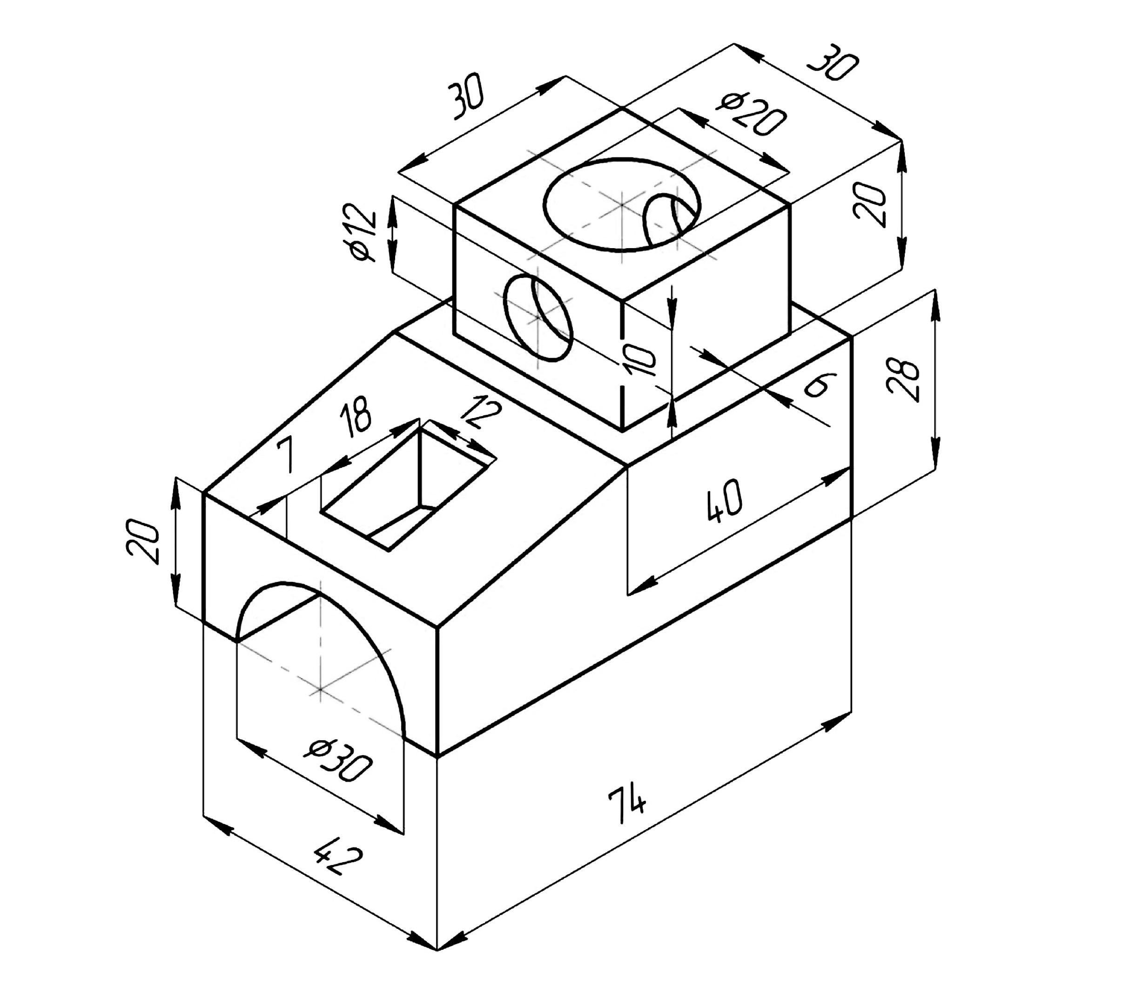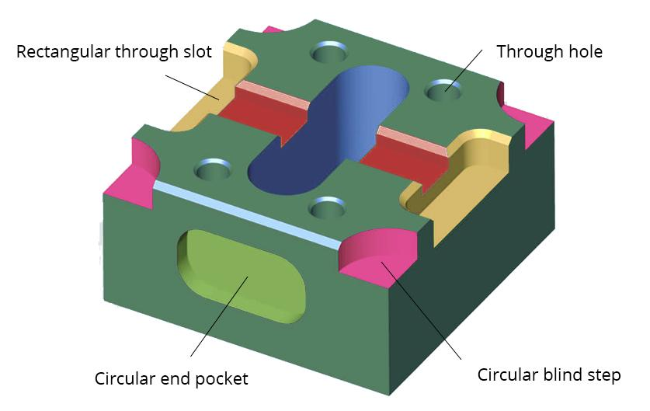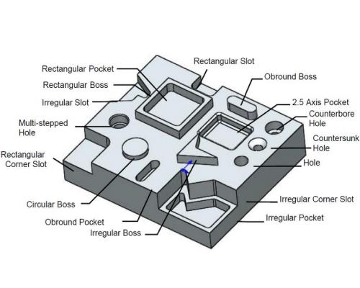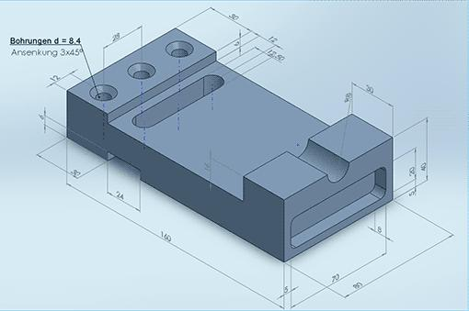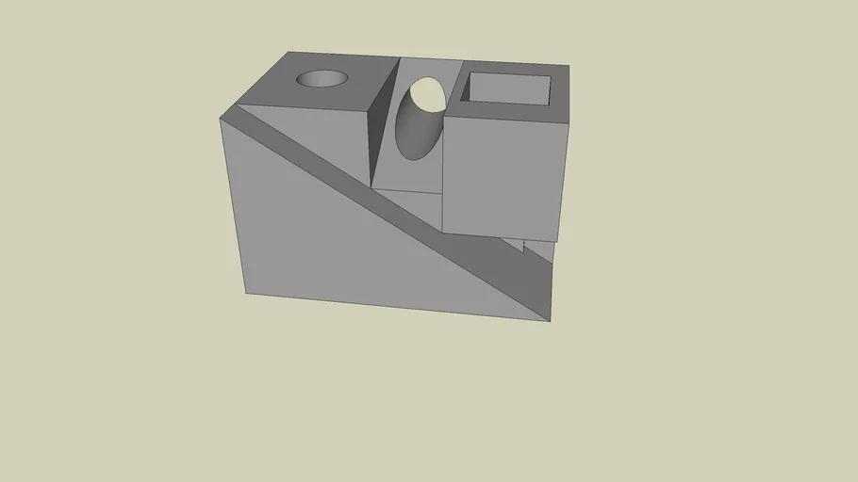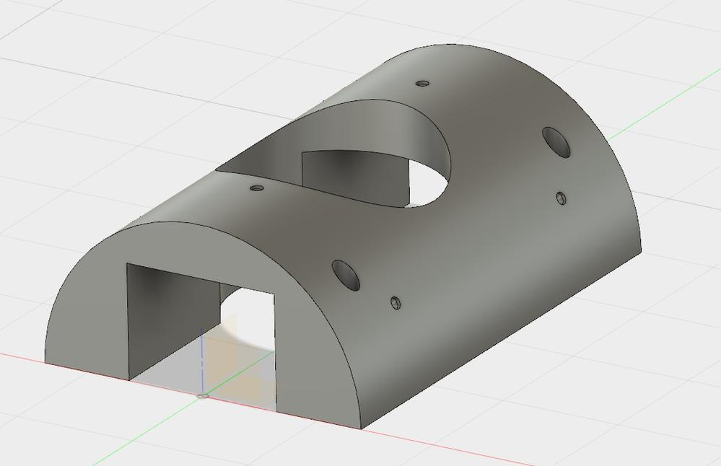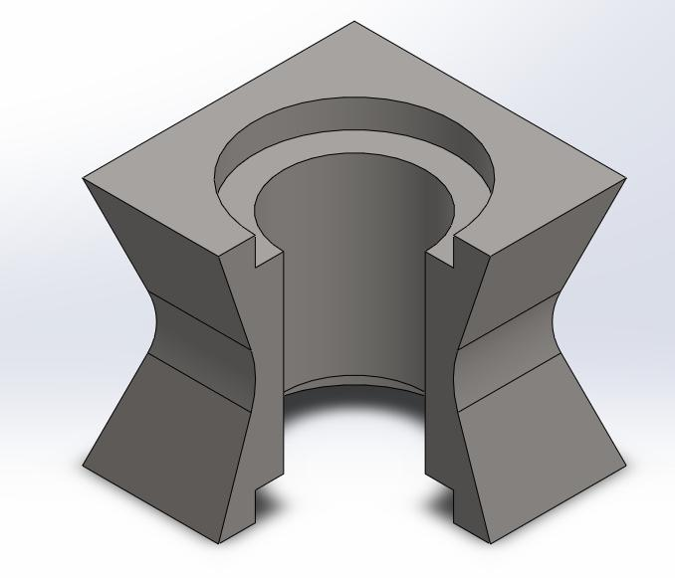
Main Components
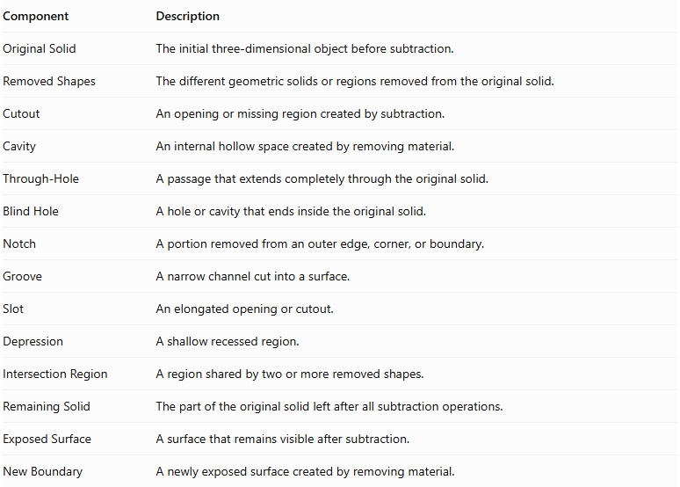
Component | Description
Original Solid | The initial three-dimensional object before subtraction.
Removed Shapes | The different geometric solids or regions removed from the original solid.
Cutout | An opening or missing region created by subtraction.
Cavity | An internal hollow space created by removing material.
Through-Hole | A passage that extends completely through the original solid.
Blind Hole | A hole or cavity that ends inside the original solid.
Notch | A portion removed from an outer edge, corner, or boundary.
Groove | A narrow channel cut into a surface.
Slot | An elongated opening or cutout.
Depression | A shallow recessed region.
Intersection Region | A region shared by two or more removed shapes.
Remaining Solid | The part of the original solid left after all subtraction operations.
Exposed Surface | A surface that remains visible after subtraction.
New Boundary | A newly exposed surface created by removing material.

Types of Mixed-Shape Subtraction

Prism-Based Mixed-Shape Subtraction
# Source: AI Source: Provided by: [Data Path: Persons Table -> ID Column: 1, Name_En Column: Motasem Essam] -> From: [ChatGPT] on [7/25/2026]
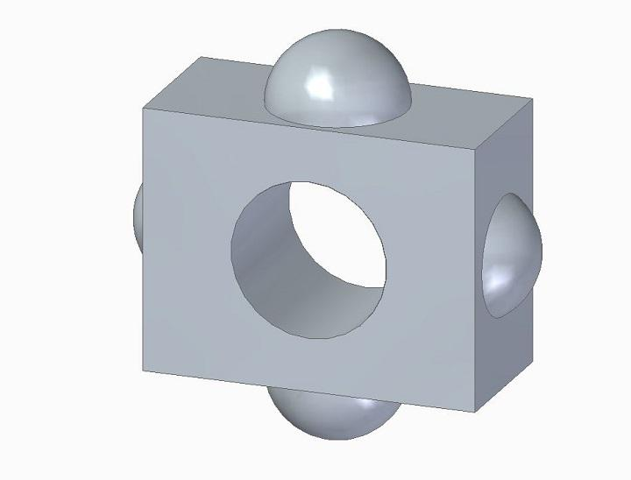
Different geometric shapes are removed from an original prism.
Examples:
- Cylindrical hole with rectangular notch.
- Conical cavity with cylindrical hole.
- Spherical cavity with triangular cutout.
- Multiple cylindrical and pyramidal cutouts.

Cylinder-Based Mixed-Shape Subtraction
# Source: AI Source: Provided by: [Data Path: Persons Table -> ID Column: 1, Name_En Column: Motasem Essam] -> From: [ChatGPT] on [7/25/2026]
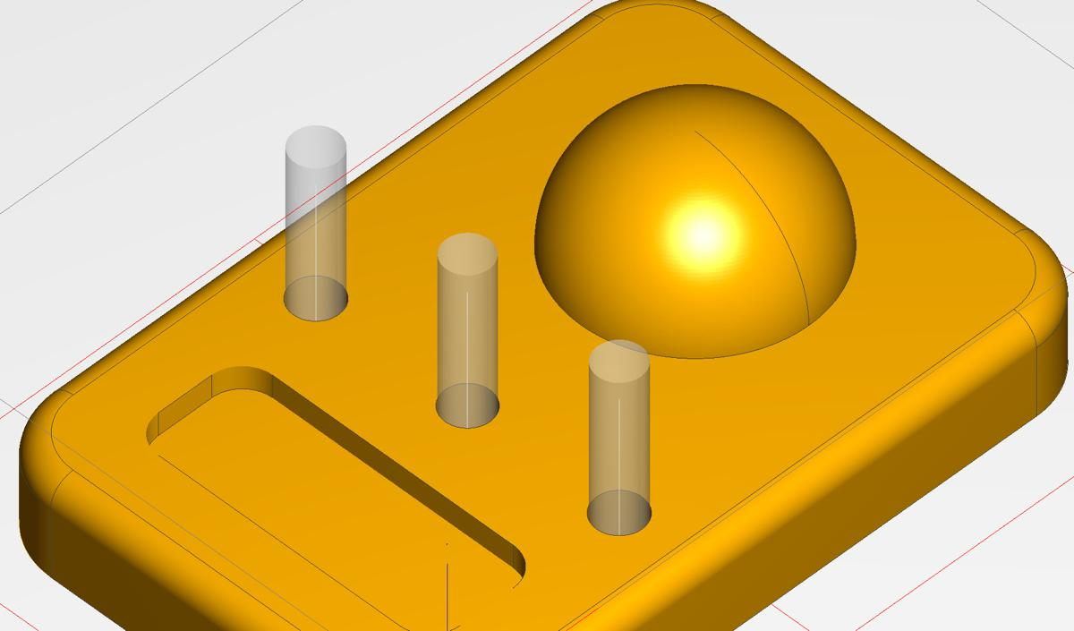
Different geometric shapes are removed from an original cylinder.
Examples:
- Cylindrical solid with rectangular notch and conical cavity.
- Cylinder with spherical depression and cylindrical through-hole.
- Cylinder with triangular-prism cutout.
- Cylinder with multiple mixed-shaped cavities.

Cone-Based Mixed-Shape Subtraction
# Source: AI Source: Provided by: [Data Path: Persons Table -> ID Column: 1, Name_En Column: Motasem Essam] -> From: [ChatGPT] on [7/25/2026]
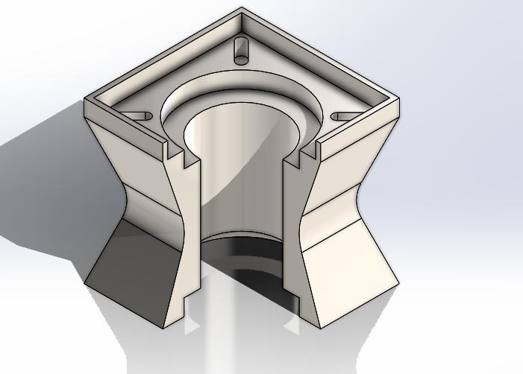
Different geometric shapes are removed from an original cone.
Examples:
- Cone with cylindrical hole and rectangular notch.
- Cone with spherical cavity and conical cutout.
- Cone with pyramidal and cylindrical cavities.
- Cone with multiple mixed-shaped cutouts.

Pyramid-Based Mixed-Shape Subtraction
# Source: AI Source: Provided by: [Data Path: Persons Table -> ID Column: 1, Name_En Column: Motasem Essam] -> From: [ChatGPT] on [7/25/2026]
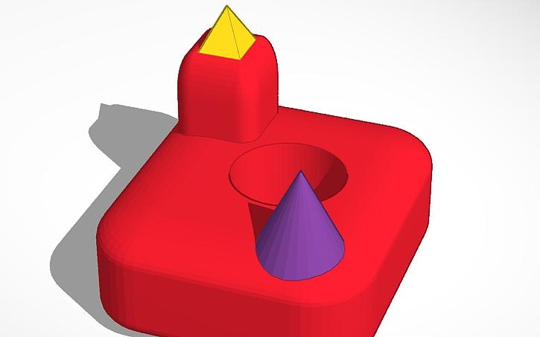
Different geometric shapes are removed from an original pyramid.
Examples:
- Pyramid with cylindrical hole and rectangular notch.
- Pyramid with spherical cavity and conical cutout.
- Pyramid with triangular-prism and cylindrical cutouts.
- Pyramid with multiple mixed-shaped cavities.

Sphere-Based Mixed-Shape Subtraction
# Source: AI Source: Provided by: [Data Path: Persons Table -> ID Column: 1, Name_En Column: Motasem Essam] -> From: [ChatGPT] on [7/25/2026]
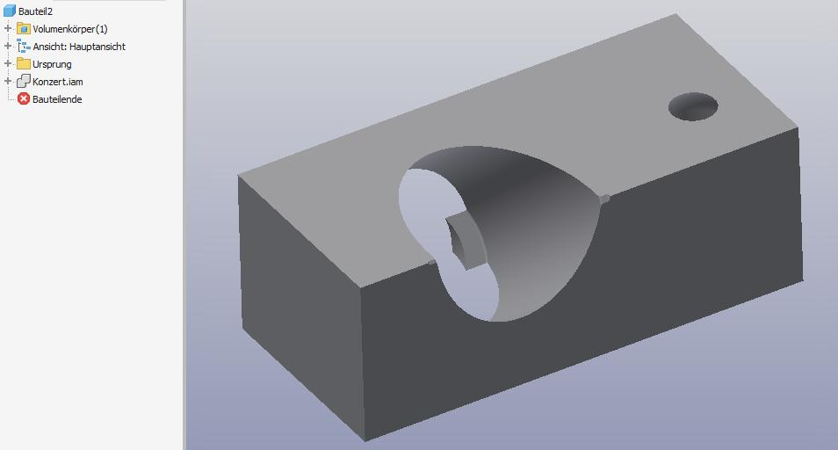
Different geometric shapes are removed from an original sphere.
Examples:
- Sphere with cylindrical hole and spherical cavity.
- Sphere with conical depression and rectangular cutout.
- Sphere with cylindrical tunnel and pyramidal cavity.
- Sphere with multiple mixed-shaped openings.

Multi-Solid Mixed-Shape Subtraction
# Source: AI Source: Provided by: [Data Path: Persons Table -> ID Column: 1, Name_En Column: Motasem Essam] -> From: [ChatGPT] on [7/25/2026]
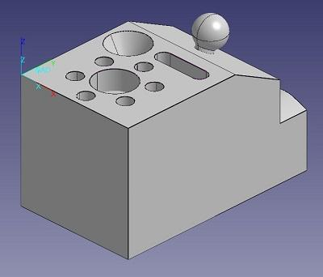
Different geometric shapes are removed from an original composite solid containing two or more connected solid types.
Examples:
- Prism-cylinder composite with cylindrical and conical cutouts.
- Cylinder-cone composite with spherical and rectangular cutouts.
- Pyramid-prism composite with cylindrical and pyramidal cavities.
- Multiple connected solids with different cutout shapes.

Classification by Combination of Removed Shapes
# Source: AI Source: Provided by: [Data Path: Persons Table -> ID Column: 1, Name_En Column: Motasem Essam] -> From: [ChatGPT] on [7/25/2026]
Mixed-Shape Subtraction can be classified according to the geometric shapes used in the removal process.
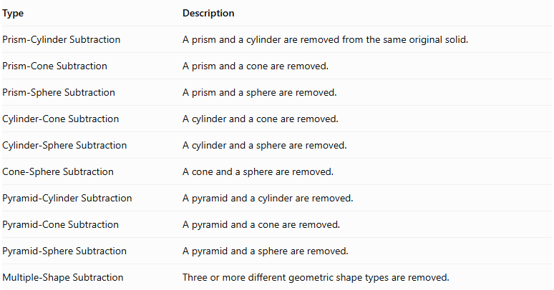
Type | Description
Prism-Cylinder Subtraction | A prism and a cylinder are removed from the same original solid.
Prism-Cone Subtraction | A prism and a cone are removed.
Prism-Sphere Subtraction | A prism and a sphere are removed.
Cylinder-Cone Subtraction | A cylinder and a cone are removed.
Cylinder-Sphere Subtraction | A cylinder and a sphere are removed.
Cone-Sphere Subtraction | A cone and a sphere are removed.
Pyramid-Cylinder Subtraction | A pyramid and a cylinder are removed.
Pyramid-Cone Subtraction | A pyramid and a cone are removed.
Pyramid-Sphere Subtraction | A pyramid and a sphere are removed.
Multiple-Shape Subtraction | Three or more different geometric shape types are removed.

Classification by Location of Subtraction
# Source: AI Source: Provided by: [Data Path: Persons Table -> ID Column: 1, Name_En Column: Motasem Essam] -> From: [ChatGPT] on [7/25/2026]
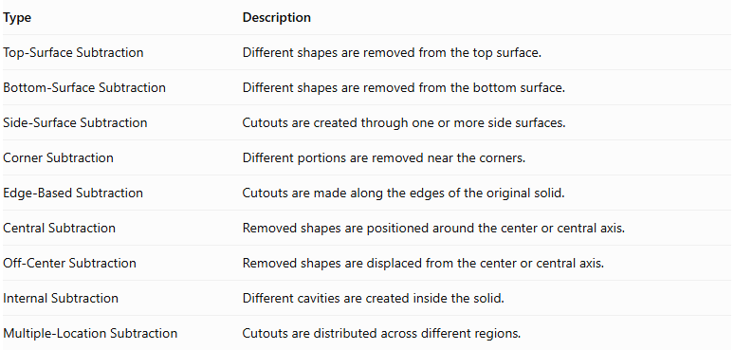
Type | Description
Top-Surface Subtraction | Different shapes are removed from the top surface.
Bottom-Surface Subtraction | Different shapes are removed from the bottom surface.
Side-Surface Subtraction | Cutouts are created through one or more side surfaces.
Corner Subtraction | Different portions are removed near the corners.
Edge-Based Subtraction | Cutouts are made along the edges of the original solid.
Central Subtraction | Removed shapes are positioned around the center or central axis.
Off-Center Subtraction | Removed shapes are displaced from the center or central axis.
Internal Subtraction | Different cavities are created inside the solid.
Multiple-Location Subtraction | Cutouts are distributed across different regions.

Classification by Subtraction Method
# Source: AI Source: Provided by: [Data Path: Persons Table -> ID Column: 1, Name_En Column: Motasem Essam] -> From: [ChatGPT] on [7/25/2026]
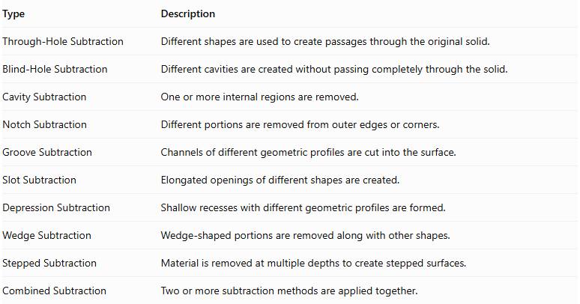
Type | Description
Through-Hole Subtraction | Different shapes are used to create passages through the original solid.
Blind-Hole Subtraction | Different cavities are created without passing completely through the solid.
Cavity Subtraction | One or more internal regions are removed.
Notch Subtraction | Different portions are removed from outer edges or corners.
Groove Subtraction | Channels of different geometric profiles are cut into the surface.
Slot Subtraction | Elongated openings of different shapes are created.
Depression Subtraction | Shallow recesses with different geometric profiles are formed.
Wedge Subtraction | Wedge-shaped portions are removed along with other shapes.
Stepped Subtraction | Material is removed at multiple depths to create stepped surfaces.
Combined Subtraction | Two or more subtraction methods are applied together.

Classification by Number and Arrangement
# Source: AI Source: Provided by: [Data Path: Persons Table -> ID Column: 1, Name_En Column: Motasem Essam] -> From: [ChatGPT] on [7/25/2026]
- Double-Shape Subtraction: Two different geometric shape types are removed.
- Triple-Shape Subtraction: Three different geometric shape types are removed.
- Multiple-Shape Subtraction: Four or more different geometric shape types are removed.
- Repeated Mixed-Shape Subtraction: Different shape combinations are repeated in multiple locations.
- Sequential Subtraction: Shapes are removed one after another.
- Simultaneous Subtraction: Multiple removed regions are treated as one combined subtraction operation.
- Symmetrical Subtraction: Different cutouts are arranged symmetrically.
- Asymmetrical Subtraction: Different cutouts are arranged without symmetry.
- Uniform Subtraction: Repeated cutouts have consistent dimensions or spacing.
- Non-Uniform Subtraction: Cutouts differ in dimensions, shapes, or spacing.
- Axial Subtraction: Removed shapes are aligned along a common reference axis.
- Radial Subtraction: Cutouts are arranged around a central axis.
- Distributed Subtraction: Different cutouts are positioned across several regions of the original solid.

Mathematical Properties and Formulas

Remaining Volume After Mixed-Shape Subtraction
# Source: AI Source: Provided by: [Data Path: Persons Table -> ID Column: 1, Name_En Column: Motasem Essam] -> From: [ChatGPT] on [7/25/2026]
The general formula is:
$$V_{remaining}=V_{original}-V_{removed}$$
For multiple non-overlapping removed shapes:
$$V_{remaining}=V_{original}-(V_{1}+V_{2}+⋯+V_{n})$$
Where:
- $V_{original}$ = volume of the original solid.
- $V_{1},V_{2},…,V_{n}$ = volumes of the different removed shapes.
- $n$ = number of removed portions.
Important: If removed shapes overlap, their intersection volumes must be accounted for so that the same region is not subtracted more than once.

Volume Formulas of Common Removed Shapes
# Source: AI Source: Provided by: [Data Path: Persons Table -> ID Column: 1, Name_En Column: Motasem Essam] -> From: [ChatGPT] on [7/25/2026]
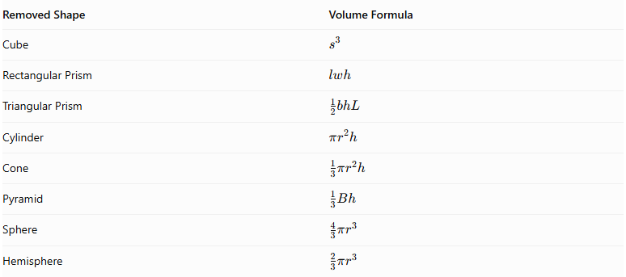
Removed Shape | Volume Formula
Cube | $$s^{3}$$
Rectangular Prism | $$lwh$$
Triangular Prism | $$\frac{1}{2}bhL$$
Cylinder | $$πr^{2}h$$
Cone | $$\frac{1}{3}πr^{2}h$$
Pyramid | $$\frac{1}{3}Bh$$
Sphere | $$\frac{4}{3}πr^{3}$$
Hemisphere | $$\frac{2}{3}πr^{3}$$

Surface Area After Mixed-Shape Subtraction
# Source: AI Source: Provided by: [Data Path: Persons Table -> ID Column: 1, Name_En Column: Motasem Essam] -> From: [ChatGPT] on [7/25/2026]
$${SA}_{remaining}={SA}_{original}-{SA}_{removed boundary}+{SA}_{newly exposed}$$
Surface area calculations require identifying:
- Original external surfaces that remain exposed.
- Portions of the original surface that become openings.
- New internal surfaces created by the cutouts.
- Intersections between different cutouts.
- Any surfaces shared by overlapping removed regions.
Important: Do not simply subtract the total surface areas of the removed solids. Only the original boundary portions that disappear should be subtracted, while newly exposed surfaces should be added.

Surface Area of Common Newly Exposed Shapes
# Source: AI Source: Provided by: [Data Path: Persons Table -> ID Column: 1, Name_En Column: Motasem Essam] -> From: [ChatGPT] on [7/25/2026]
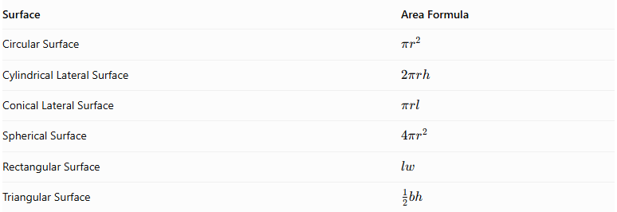
Surface | Area Formula
Circular Surface | $$πr^{2}$$
Cylindrical Lateral Surface | $$2πrh$$
Conical Lateral Surface | $$πrl$$
Spherical Surface | $$4πr^{2}$$
Rectangular Surface | $$lw$$
Triangular Surface | $$\frac{1}{2}bh$$
These formulas are used only for the actual exposed portions of the corresponding surfaces.

Worked Examples

Example 1: Rectangular Prism with Cylindrical and Conical Cutouts
# Source: AI Source: Provided by: [Data Path: Persons Table -> ID Column: 1, Name_En Column: Motasem Essam] -> From: [ChatGPT] on [7/25/2026]
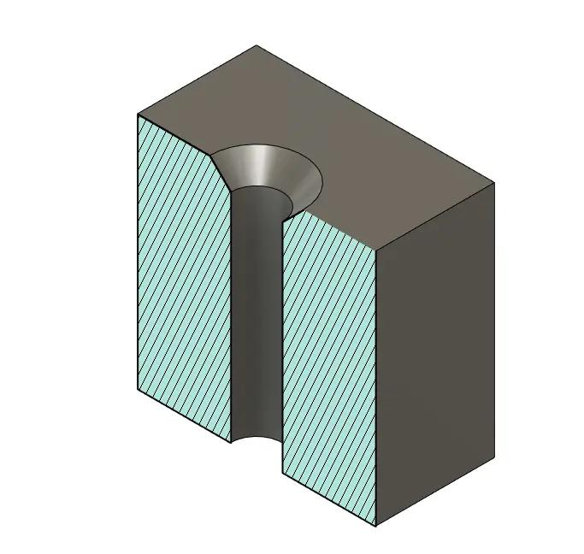
Given:
Original rectangular prism:
- Length: $L=12 cm$
- Width: $W=8 cm$
- Height: $H=6 cm$
Removed portions:
Cylindrical through-hole:
- Radius: $r_{1}=1 cm$
- Height: $h_{1}=6 cm$
Conical blind cavity:
- Radius: $r_{2}=2 cm$
- Height: $h_{2}=3 cm$
Assume the two cutouts are separate and do not overlap.
Step 1: Calculate the original prism volume.
$$V_{original}=LWH$$
$$V_{original}=12(8)(6)=576{ cm}^{3}$$
Step 2: Calculate the cylindrical hole volume.
$$V_{cylinder}=πr_{1}^{2}h_{1}$$
$$V_{cylinder}=π(1)^{2}(6)=6π$$
Step 3: Calculate the conical cavity volume.
$$V_{cone}=\frac{1}{3}πr_{2}^{2}h_{2}$$
$$V_{cone}=\frac{1}{3}π(2)^{2}(3)=4π$$
Step 4: Calculate the total removed volume.
$$V_{removed}=6π+4π=10π$$
Step 5: Calculate the remaining volume.
$$V_{remaining}=576-10π$$
$$\boxed{V_{remaining}≈544.58{ cm}^{3}}$$
Step 6: Calculate the original surface area.
$${SA}_{original}=2(LW+LH+WH)$$
$$=2(96+72+48)=432{ cm}^{2}$$
Step 7: Calculate the surface area after subtraction.
For the cylindrical through-hole:
- Two circular openings are removed: $2π(1)^{2}=2π$.
- The new cylindrical inner wall is added: $2π(1)(6)=12π$.
For the conical blind cavity:
- One circular opening is removed: $4π$.
- The new conical lateral surface is added.
Its slant height is:
$$l=\sqrt{2^{2}+3^{2}}=\sqrt{13}$$
$${LSA}_{cone}=π(2)\sqrt{13}=2π\sqrt{13}$$
Therefore:
$${SA}_{remaining}=432-2π-4π+12π+2π\sqrt{13}$$
$$\boxed{{SA}_{remaining}≈495.26{ cm}^{2}}$$
Conclusion: The rectangular prism has two different cutout types: a cylindrical through-hole and a conical blind cavity. Both reduce its volume and create new internal surfaces.

Example 2: Cube with Cylindrical and Rectangular Cutouts
# Source: AI Source: Provided by: [Data Path: Persons Table -> ID Column: 1, Name_En Column: Motasem Essam] -> From: [ChatGPT] on [7/25/2026]
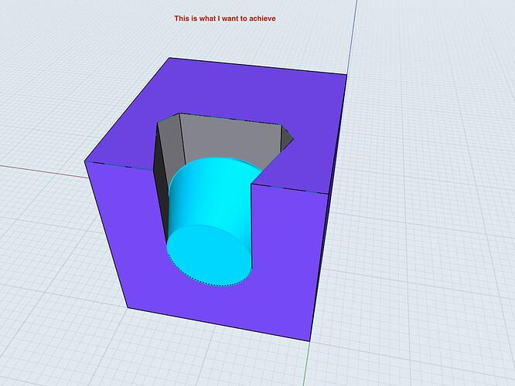
Given:
Original cube:
- Side length: $s=10 cm$
Removed portions:
Cylindrical through-hole:
- Radius: $r=1 cm$
- Height: $h=10 cm$
Rectangular blind cavity:
- Length: $a=3 cm$
- Width: $b=2 cm$
- Depth: $d=2 cm$
Assume the cutouts are separate and do not overlap.
Step 1: Calculate the original cube volume.
$$V_{original}=s^{3}={10}^{3}=1000{ cm}^{3}$$
Step 2: Calculate the cylindrical hole volume.
$$V_{cylinder}=πr^{2}h$$
$$V_{cylinder}=10π{ cm}^{3}$$
Step 3: Calculate the rectangular cavity volume.
$$V_{cavity}=abd$$
$$V_{cavity}=3(2)(2)=12{ cm}^{3}$$
Step 4: Calculate the remaining volume.
$$V_{remaining}=1000-10π-12$$
$$\boxed{V_{remaining}≈956.58{ cm}^{3}}$$
Step 5: Calculate the original cube surface area.
$${SA}_{original}=6s^{2}$$
$${SA}_{original}=6(10)^{2}=600{ cm}^{2}$$
Step 6: Calculate the cylindrical hole surface-area change.
Two circular openings are removed:
$$A_{openings}=2π(1)^{2}=2π$$
The new cylindrical inner wall is:
$$A_{inner}=2π(1)(10)=20π$$
Net change:
$$Δ{SA}_{cylinder}=20π-2π=18π$$
Step 7: Calculate the rectangular cavity surface-area change.
The opening and cavity bottom have equal areas:
$$A_{opening}=A_{bottom}=3(2)=6$$
These areas cancel. The four newly exposed walls have a total area of:
$$A_{walls}=2d(a+b)$$
$$=2(2)(3+2)=20{ cm}^{2}$$
Step 8: Calculate the final surface area.
$${SA}_{remaining}=600+18π+20$$
$$\boxed{{SA}_{remaining}≈676.55{ cm}^{2}}$$
Conclusion: The cube contains two different subtraction features: a cylindrical through-hole and a rectangular blind cavity. Each creates a different type of newly exposed internal surface.
Correction to Example 1: The final surface-area arithmetic should be:
$${SA}_{remaining}=432+6π+2π\sqrt{13}$$
$$\boxed{{SA}_{remaining}≈473.50{ cm}^{2}}$$
The previously displayed value of $495.26{ cm}^{2}$ was an arithmetic error.

Important Characteristics
# Source: AI Source: Provided by: [Data Path: Persons Table -> ID Column: 1, Name_En Column: Motasem Essam] -> From: [ChatGPT] on [7/25/2026]
- Multiple Shape Types: Two or more different geometric shapes are removed from the original solid.
- Material Removal: Each subtraction operation removes a specific portion of the original object.
- Volume Reduction: The remaining volume decreases according to the total removed volume.
- Surface Modification: Different cutouts create different types of exposed surfaces.
- Flexible Combinations: Removed shapes may include prisms, cylinders, cones, pyramids, and spheres.
- Variable Locations: Cutouts may be positioned on top, bottom, sides, corners, edges, or inside the original solid.
- Different Depths: Cutouts may be through-holes or blind cavities with different depths.
- Complex Geometry: Multiple subtraction operations can produce irregular and complicated three-dimensional objects.
- Overlapping Cutouts: Intersections between removed shapes must be considered to avoid double-counting removed volume.

Comparison with Other Subtraction Types
# Source: AI Source: Provided by: [Data Path: Persons Table -> ID Column: 1, Name_En Column: Motasem Essam] -> From: [ChatGPT] on [7/25/2026]
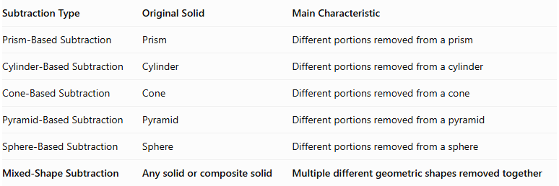
Subtraction Type | Original Solid | Main Characteristic
Prism-Based Subtraction | Prism | Different portions removed from a prism
Cylinder-Based Subtraction | Cylinder | Different portions removed from a cylinder
Cone-Based Subtraction | Cone | Different portions removed from a cone
Pyramid-Based Subtraction | Pyramid | Different portions removed from a pyramid
Sphere-Based Subtraction | Sphere | Different portions removed from a sphere
Mixed-Shape Subtraction | Any solid or composite solid | Multiple different geometric shapes removed together

Applications
# Source: AI Source: Provided by: [Data Path: Persons Table -> ID Column: 1, Name_En Column: Motasem Essam] -> From: [ChatGPT] on [7/25/2026]
- Mechanical Engineering: Designing complex mechanical components with different holes, cavities, and slots.
- Manufacturing: Producing parts with multiple cutout shapes and dimensions.
- Automotive Engineering: Creating components with cylindrical passages, conical recesses, and rectangular openings.
- Architecture: Designing structural components with multiple geometric openings.
- Product Design: Creating objects with different cavities, grooves, and decorative cutouts.
- CAD Modeling: Building complex objects using Boolean difference operations.
- Industrial Design: Developing components with different functional openings and recessed regions.
- Education: Teaching volume subtraction, surface-area calculations, and geometric intersections.

Key Points
# Source: AI Source: Provided by: [Data Path: Persons Table -> ID Column: 1, Name_En Column: Motasem Essam] -> From: [ChatGPT] on [7/25/2026]
- Mixed-Shape Subtraction involves removing two or more different geometric shape types from an original solid.
- It can be applied to prisms, cylinders, cones, pyramids, spheres, and composite solids.
- Removed portions may include cylindrical holes, conical cavities, spherical cutouts, and rectangular notches.
- The remaining volume is calculated by subtracting the combined removed volume from the original volume, accounting for intersections.
- Surface area must account for removed original boundary surfaces and newly exposed internal surfaces.
- Cutouts may be arranged symmetrically, asymmetrically, axially, radially, or irregularly.
- Different subtraction methods can be combined in a single solid.
- Mixed-Shape Subtraction is useful for modeling complex manufactured and mechanical components.

Conclusion
# Source: AI Source: Provided by: [Data Path: Persons Table -> ID Column: 1, Name_En Column: Motasem Essam] -> From: [ChatGPT] on [7/25/2026]
Mixed-Shape Subtraction is a method of forming composite solids by removing two or more different geometric shapes from an original solid or composite solid.
It combines different subtraction operations, such as cylindrical holes, conical cavities, spherical depressions, and rectangular notches, to create complex three-dimensional structures.
Its mathematical analysis involves calculating the remaining volume, accounting for overlapping removed regions, and determining all exposed surfaces after subtraction. It is an important concept in solid geometry, engineering, manufacturing, CAD modeling, and industrial design.

